Data Visualization: Assignment 4

Student 1: Jan Gruszczyński

Student 2: Kacper Trębacz

# Design

# Subreddit Analyzer

# Analysis of subreddits on reddit. Data used in the analyzer was scrapped by us, using our own scrapper, it is updated periodically, we try to add the data constantly, but as for now, only a portion of picked subreddits are available. The analyzer show plenty of interesting graphs, most of them are interactive. For example it graphs a map, which shows popularity of picked subreddits in certain countries, and by clicking on a country the user can check the most popular subreddits in a certain country. (We checked that using a bit of magic). The dashboard futures also a wordmap creator, histograms, scatter plots, conversation meters (with our own distinct metric). Almost everything is interactive.

# Tasks solved using the dashboard

1. Dashboard introduces the user to a subreddit, showing most important information about certain subreddit.
2. The dashboard can be used for sentiment analysis, social analysis and more. One can check what is popular in certain country, or vice-versa which countries visit certain subreddit.
3. Project gathers data about subreddits and it’s users, then it visualizes it.

# Sketches

# 

# 

# Implementation

<https://github.com/FirstGalacticEmpire/reddit_dashboard>

Platform: Dash + Heroku

Screenshots:

# 

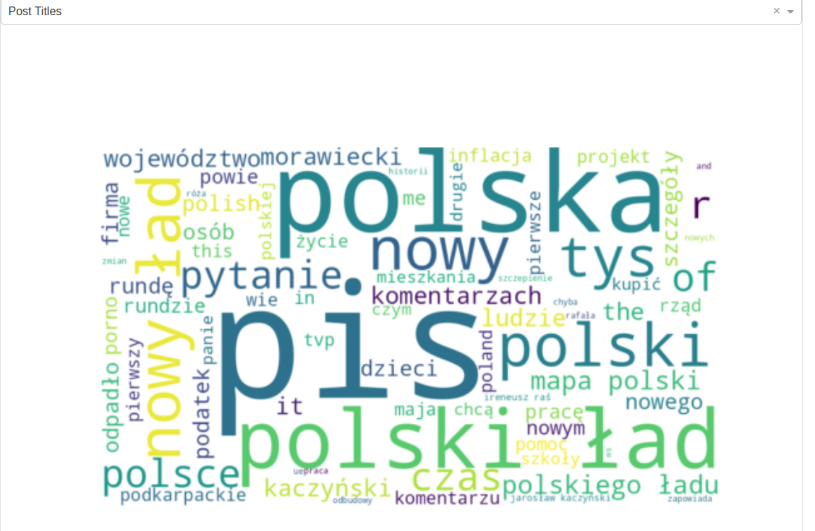

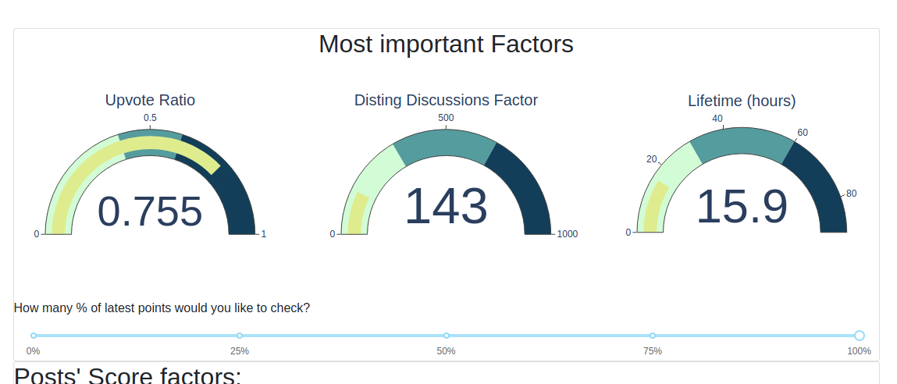

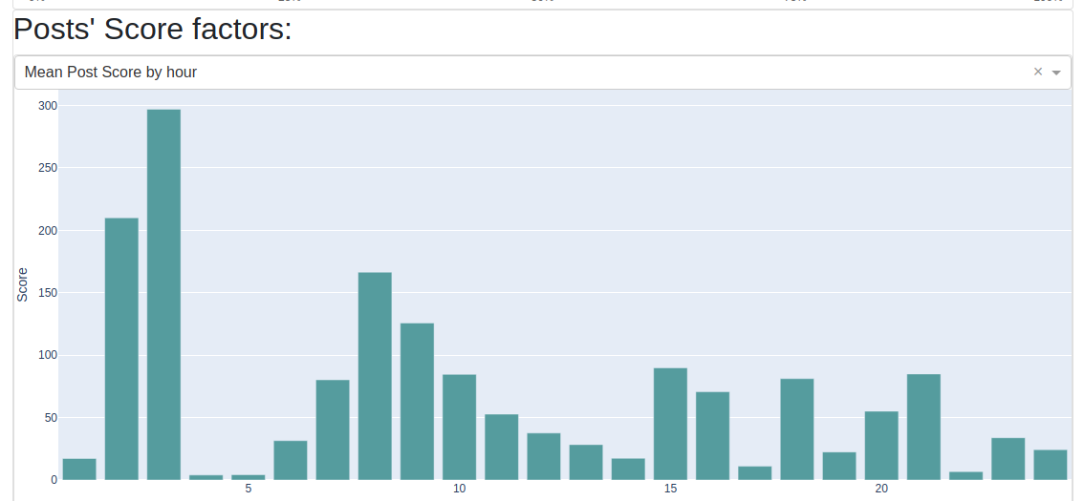

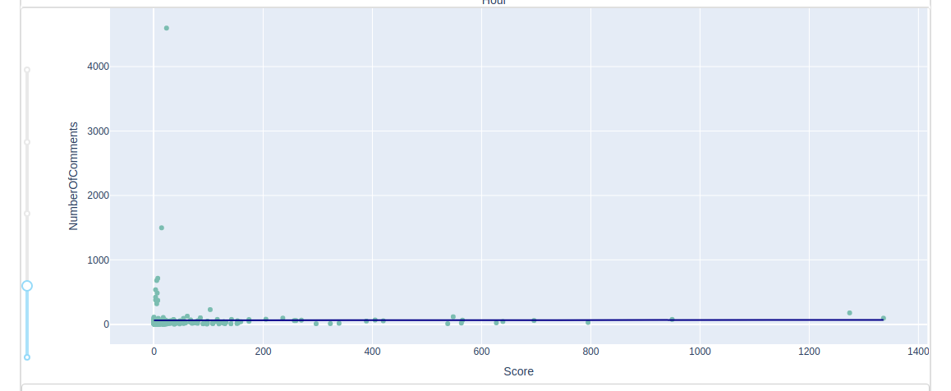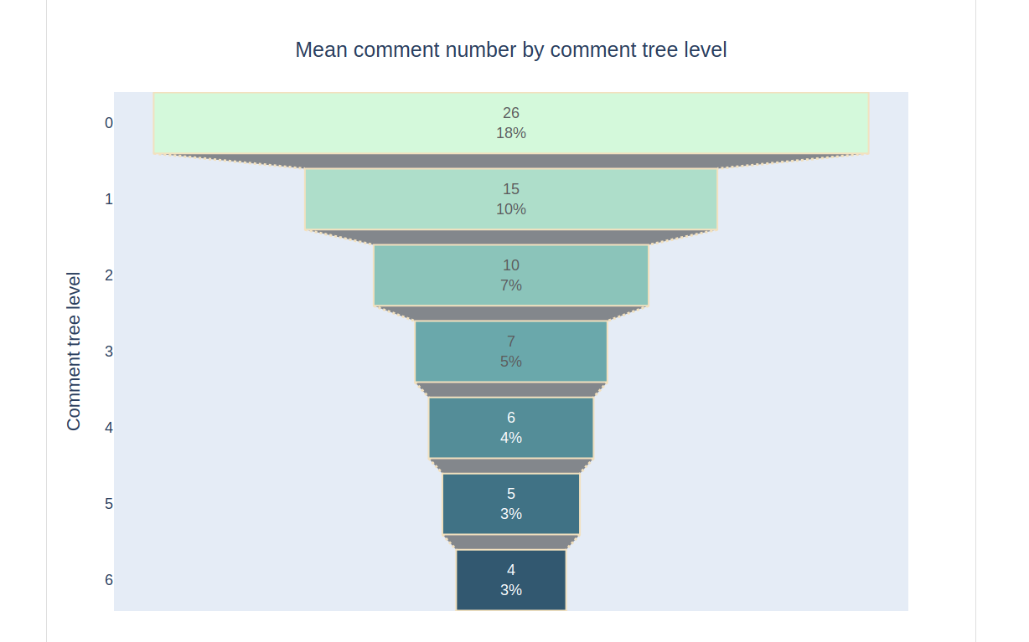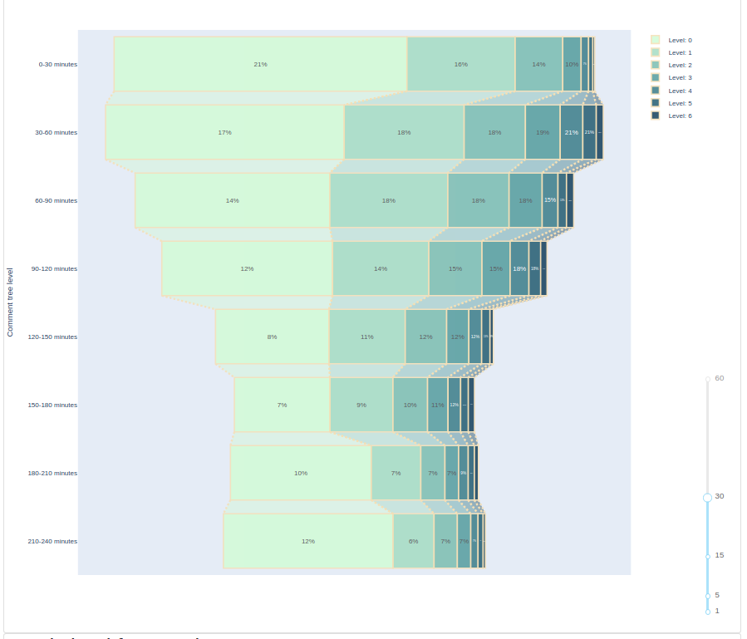

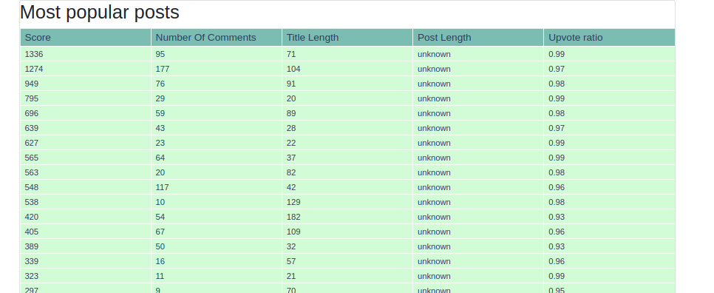

Github:

https://github.com/FirstGalacticEmpire/reddit_dashboard

Live demo:

<https://subreddit-dashboard.herokuapp.com/home>